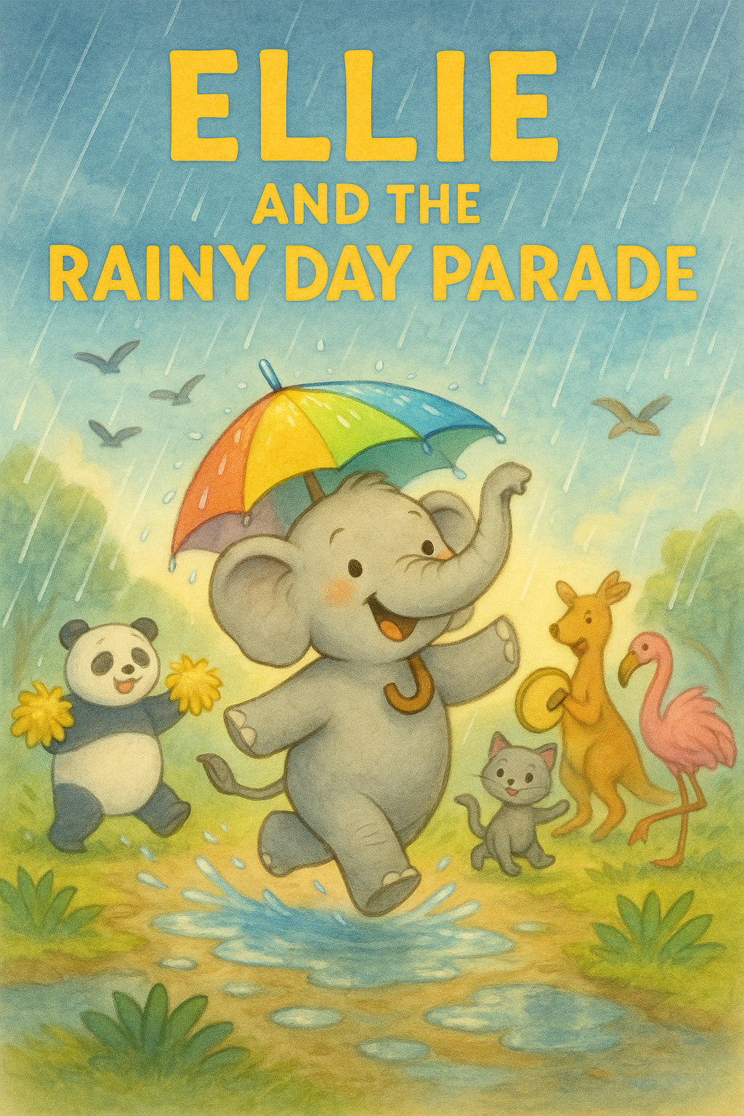

Ellie, a small elephant, loved parades - drums, music, flags, and sparkly costumes.

Each spring her town held the Sunny Parade, and she’d practiced all year to march with her umbrella hat. She rehearsed straight‐line walking, spinning, and smiling at the crowd.

But on parade morning, she woke to dark clouds and steady rain tapping the window. Ellie frowned. “What if the parade is canceled?”

She put on her umbrella hat anyway and walked to the square. One by one, the other animals came too: pandas with pom-poms, kangaroos with tambourines, flamingos in feathers. They all looked disappointed.

The mayor, a wise old owl, fluttered to the top of a bench and said, “Friends, the rain is too heavy. We must cancel the Sunny Parade.”   
A loud sigh floated through the crowd.

“But I practiced so much,” whispered a young turtle with tap shoes. “Me too,”   
said Ellie quietly.   
Then Ellie had an idea.

She climbed onto a tree stump and called out, “What if we have a Rainy Day Parade instead? We can splash in puddles, twirl in the rain, and play soggy music!” Everyone paused.

Then the panda did a pom-pom shake. The kangaroo tapped a beat on her tambourine. So the parade began, right in the middle of the rain!

The turtle tap - danced through puddles as ducks quacked and the owl clapped along.

It wasn’t the Sunny Parade but a Rainy Day Parade filled with giggles and splashes. When it ended, everyone was soaked yet smiling. The mayor owl announced from this day - two parades each year, sun & rain. Ellie loved it.

The End.